A

IndustrialInteractionReportOn

Submittedin partialfulfilmentoftherequirementfor 7thsemester



# BachelorofTechnology

By

# Anchal Gwari

1961013

Undertheguidanceof**Mr. Rahul SinghAssistantProfessor**

# DepartmentofComputerScienceandEngineering

**DEPARTMENT OF COMPUTER SCIENCE AND APPLICTIONSGRAPHIC ERA HILL UNIVERSITY, BHIMTAL CAMPUSSATTALROAD, P.OBHOWALI**

# DISTRICT–NAINITAL–2631322022-2023

**StudentDeclaration**

I,Anchal Gwari,herebydeclarethework,whichisbeingpresentedintheindustrialtrainingreport entitled **“Dechant Music Academy Graphic DesignerInternship”** in partialfulfilment of the requirement for the awardof the degree **B.Tech** in the session 2022-2023, isan authentic record of my own work carriedout under the supervision of **“Mr. Rahul Singh”,AssistantProfessorDepartmentofCSE,Graphic Era HillUniversity,Bhimtal.**



Thematterembodiedinthisreporthasnotbeensubmittedbyusfortheawardofanyotherdegree.

Date:………………..

StudentSignature

**Certificate**

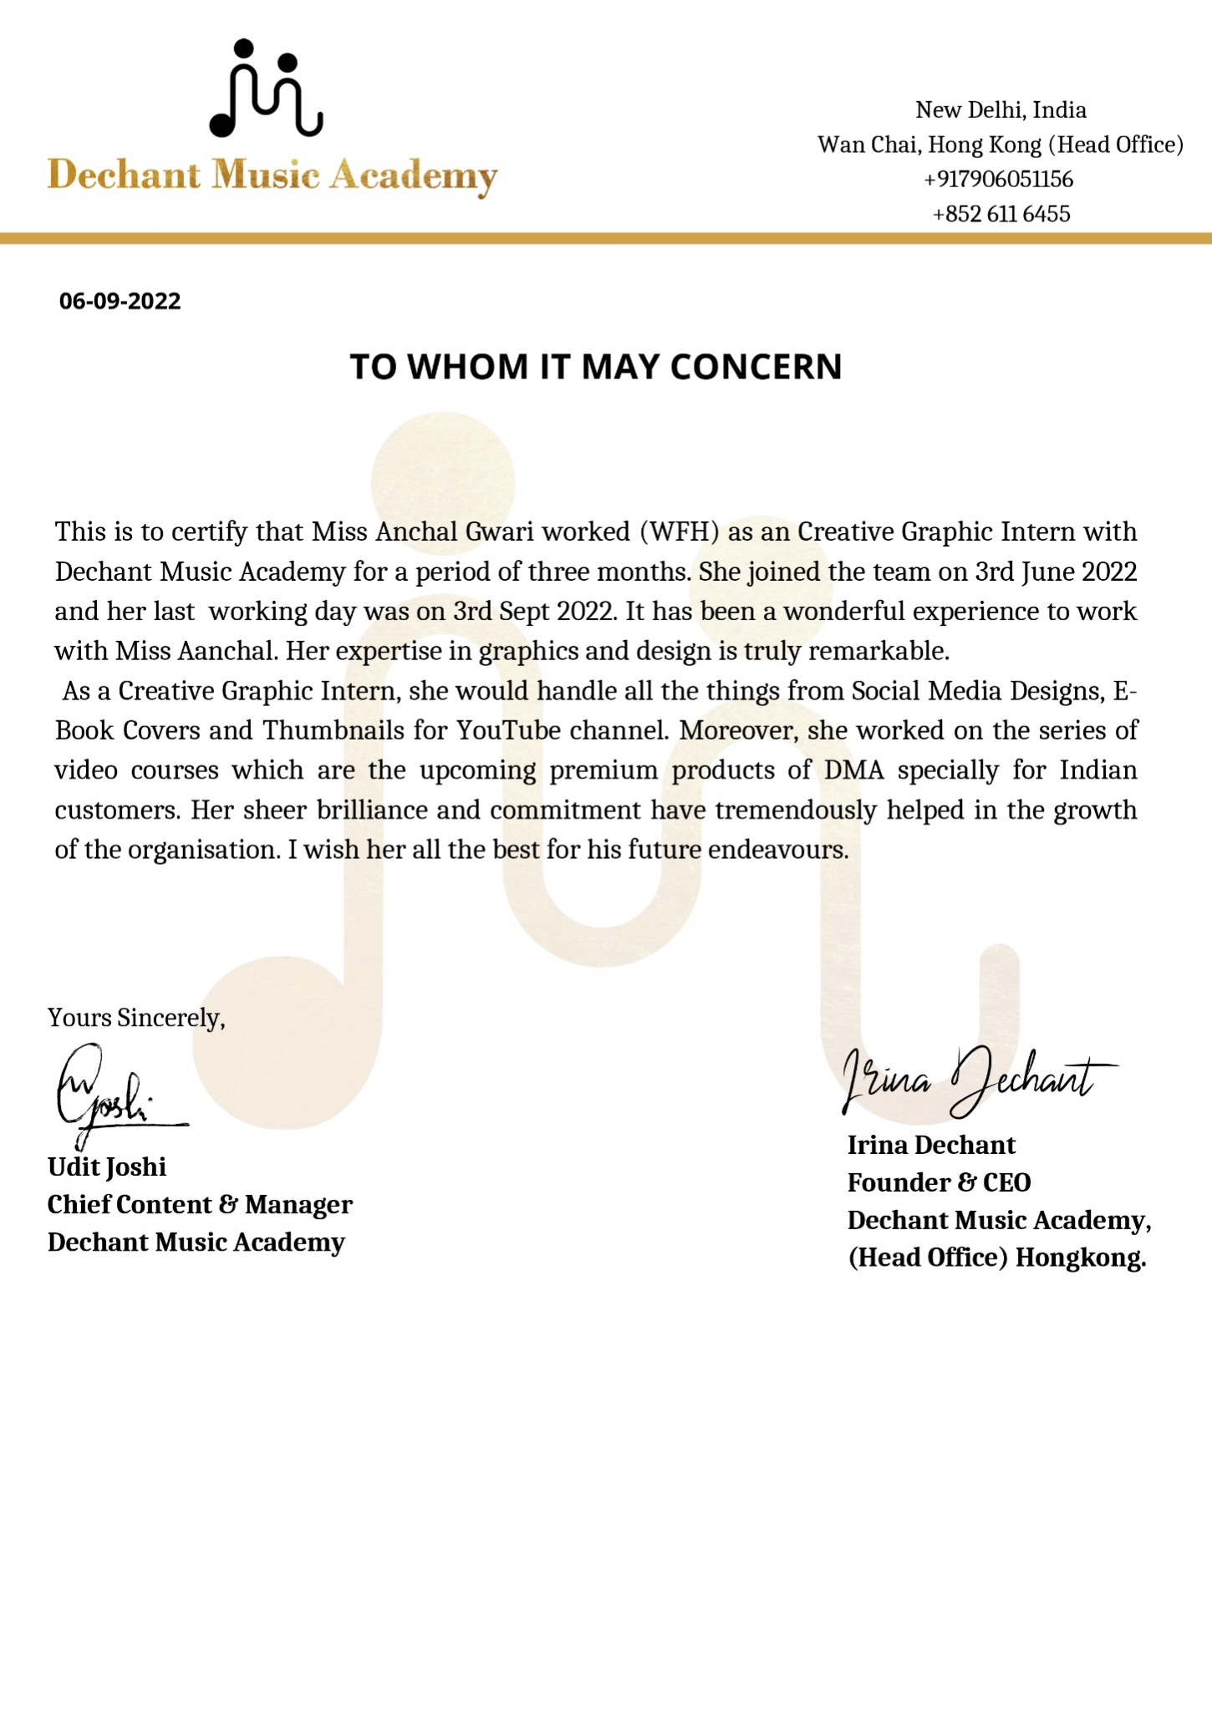

# Acknowledgement

I take immense pleasure in thanking Mr. Rahul, Mr. Udit Joshi (Chief content and manager )to provideme the golden opportunity and to permit me to work in their team. This has been possible duetotheirnovelinspiration,guidance,andsupervision.

I wish to thank my parents for their continuing support and encouragement. I also wish to thankthemforproviding us withtheopportunitytoreachthisfarinourstudies.



I would like to thank the organization “Dechant Music Academy” to whomI have been trainingand got theopportunityofcompletingmyinternship.Atlast,butnottheleast.Igreatlyindebtedtoall otherpersonswhodirectlyorindirectlyhelped usduring thiswork.

**Anchal Gwari**

**1961013**

# TableOfContents

1. StudentDeclaration 2
2. Certificate 3
3. Acknowledgement 4
4. TableOfContents 5
5. ExecutiveSummary 6
6. AboutDechant Music Academy 7
7. Technology and toolsUsed 8
8. Snapshots ofCourseCompleted 9
9. IntroductiontoGraphic Design 10
10. Snapshotsof my work  11
11. Conclusion 14

**ExecutiveSummary**

This is a 3-month virtual Internship at Dechant Music Academy, where I worked as a Graphic Intern,under the guidance of Chief Content & Manager, I experienced great team work, leadership skills, and it helped me enhancing my communication skills as I got a chance to interact with new and technically skilled people. I created book covers, thumbnails for YouTube channel and some social media designs. It was an amazing experience to work with international clients as well and to interact with them and learn about their culture.This internship not only helped me in enhancing my Graphic Designing skills but, also helped me in growing my Portfolio.



# ABOUTDECHANT MUSIC ACADEMY

Dechant Music Academy is a Music Academy based in Hong Kong. It offers to teach through offline classes and online modes as well. Dechant Music Academy was opened in 2017, but before that it was known as Irina School in 2015, as the name of founder and CEO of Dechant Music Academy is Irina Dechant. Everything started with Valentina Dechant, mother of Irina Dechant.She completed her music degree at 23 years old in accordion and piano. Afterward, she started teaching at the conservatory and privately.She began her music school in 1994 “The Dechant Private School”, and began teaching music, accordion, and piano in Germany. Irina inherited the talent and art of music from her mother and when she was completing her masters in music from Hong Kong, she started teaching music besides her studies and later on she realized that she can tech music as a full-time job also, then she opened her school, “Irina School” in 2015, she was famously known as “Irina, the Russian Piano teacher from Hong Kong”. Later in 2017 after naming the school “Dechnat Music Academy”, it became an international Music Academy, as their teachers have been from everywhere. Bosnia, London, Russia, Ukraine, Spain, Hong Kong, China, India and are now expanding the academy to other countries soon. Here, you can learn How to sing, Play the Piano, Clarinet, Guitar and many other instruments.

# 

# Technology And ToolsUsed



* Adobe Photoshop
* Adobe Illustrator
* Adobe InDesign
* Adobe color
* Canva
* Vecteezy.com (for vector arts and images)
* Pexels.com (for free HD images)

**SnapshotsofCourseCompleted**

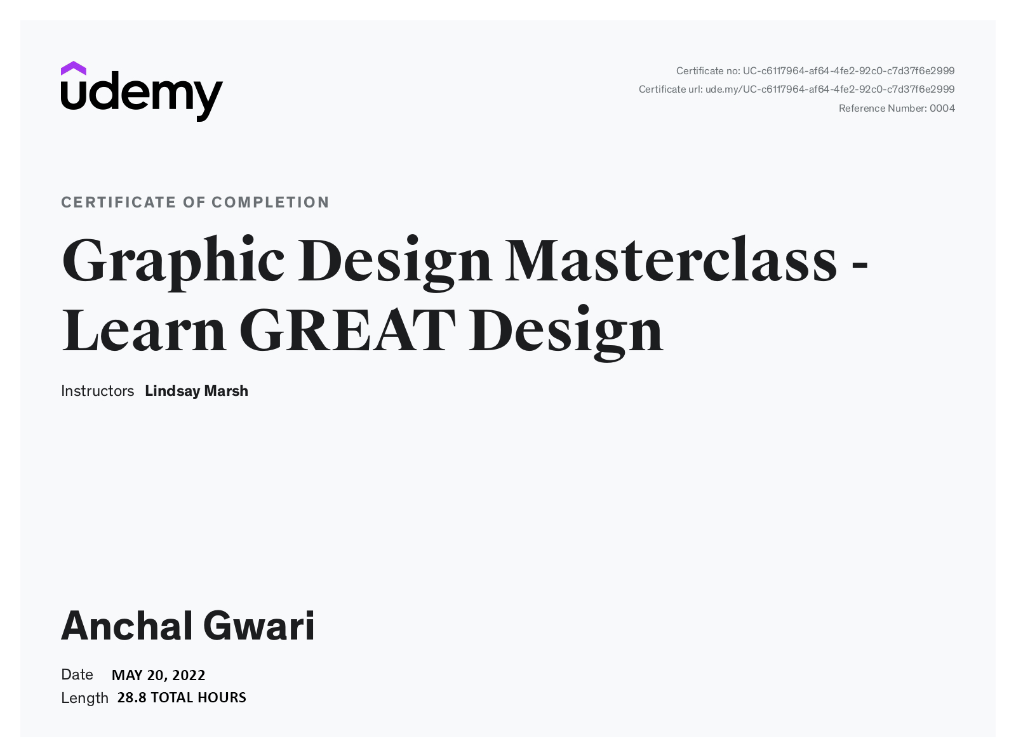

# IntroductionTo Graphic Design

Graphic design is the practice of composing and arranging the visual elements of a project.

Designing the layout of a magazine, creating a poster for a theatre performance, and designing packaging for a product are all examples of graphic design. The objective of graphic design is to convey or enhance a message.

According to the [American Institute of Graphic Arts (AIGA)](http://www.aiga.org/guide-whatisgraphicdesign), graphic design is defined as “the art and practice of planning and projecting ideas and experiences with visual and textual content.” In other terms, graphic design communicates certain ideas or messages in a visual way. These visuals can be as simple as a business logo, or as complex as page layouts on a website.

Some important elements of Graphic Design:

* Colour
* Form
* Line
* Shape
* Size
* Space
* Texture

# Keeping all these important elements of Graphic Design in my mind, I created some book covers like: puzzle books for all ages, journals covers and many more using Adobe Photoshop, Adobe InDesign and Canva.

# I also created music posters forsongsof one of my clients, using Adobe Illustrator and Photoshop. I created thumbnails for YouTube channel of my client. I also helped my teammates in series of upcoming video courses.

# Snapshots ofmy work

# 

# 

# 

# 4.

# 

# 5.

# 

# 6.

# 

**Conclusion**

I have successfully completed the 3-monthsinternship/industrial training andlearned alotfromthis.It helped me in enhancing my analytical skills, artistic abilities and communication skills.I realized where I sit within the framework.It helped me in understanding a customers need and requirements. It helped me in growing my idea generation skills as it the first thing a graphic designer will need to do when beginning a new project.



I came to know about UI and UX design, as I worked with one UI & UX designer, during the internship.I learned to create designs both visually appealing and functional.It helped in enhancing my leadership skills as I worked with a team, without panicking about the deadlines.I learned about new Designing tools like Adobe after effects, and sketch, adobe InDesign etc.